K. RAMAKRISHNAN COLLEGE OF ENGINEERING (AUTONOMOUS)

SAMAYAPURAM, TRICHY. UEC1811-PROJECT WORK

**“A METHOD AND DEVICE FOR DRY RUN PROTECTION IN DEEP WELL MOTORS”**

**PRESENTED BY:**

VIJAYABHARATH.A (ECC2158) VISHWESHWARAN.S(ECC2163) SAKTHISIDHARTHAN(ECC2119) SAKTHISARATHI.G(ECC2118)

**GUIDED BY**

Dr. B. VISWANATHAN M.S., Ph d ECE, ASSISTANT PROFESSOR, KRCE

# PROBLEM STATEMENT

* 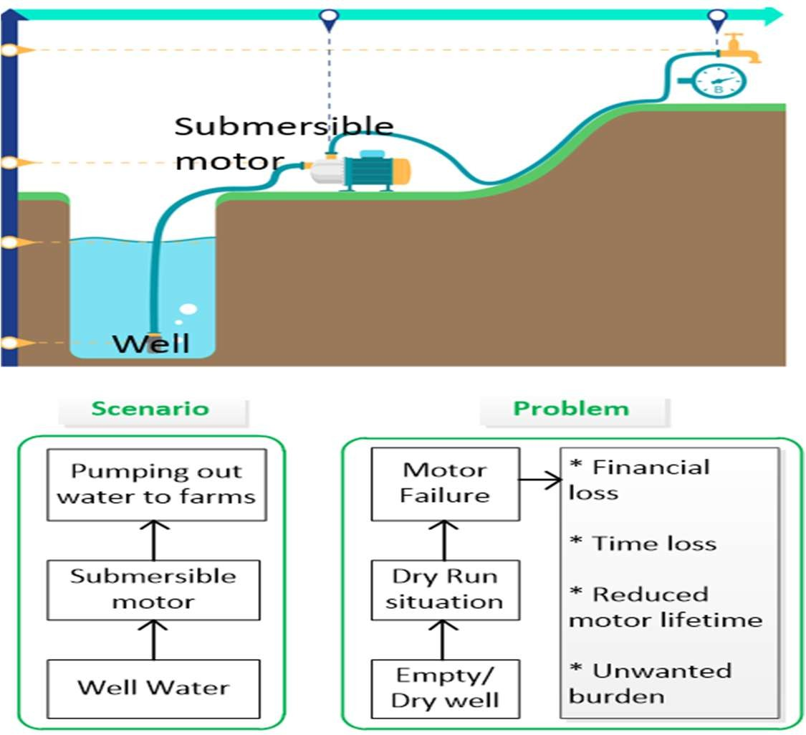**Problem:**
  + In agricultural farm wells, submersible motors are used for irrigation.
  + A frequent problem faced in such farms is “Dry Run

Situation (DRS) related motor failures (Motor keeps running even after well water has been emptied leading

to unwanted, unexpected motor repairs)”.

* + This project provides a technological solution to detect and prevent DRS motor failures and enhance motor lifetime.
* **Seriousness of the problem:**
  + DRS motor failure is a recurring problem in all agricultural farms that are unmanned or unmonitored.
  + DRS motor failures leads to:
    - Unnecessary burden for farm owners.
    - Financial loss due to motor repair or motor replacement costs.

# ABSTRACT

* The system offers intelligent dry run protection for deep well motors using a temperature-based water level sensing mechanism.
* It utilizes two NTC thermistor sensors installed at the base of the well to detect water presence through differential temperature analysis.
* The sensors are engineered with a **tapered, water-resistant design** to ensure enhanced accuracy and long- term durability.
* A smart control board integrates a **Wheatstone bridge, differential amplifier, microcontroller, and push-pull solenoid** to process sensor inputs and control motor operation.
* Upon detecting a dry run condition, the solenoid **safely deactivates the motor**, simulating a manual switch-off action.

# ADVANTAGES

## Enhanced motor lifetime

* + - No unexpected, unwanted and frequent motor repairs.
    - No financial loss. Cost savings is nearly ~7K – 10K per failure.

## Wireless IOT:

* + - Remote monitoring in addition to status indicators.
    - Manual/automatic control of motor operation using wireless IOT connectivity.

## Quick alerts and electronic control with negligible delay.

* + **Enhanced motor lifetime**
    - Time lost for motor repair incase of DRS motor failure is 1 week or more. This time loss is saved through our product.

**BLOCK DIAGRAM**

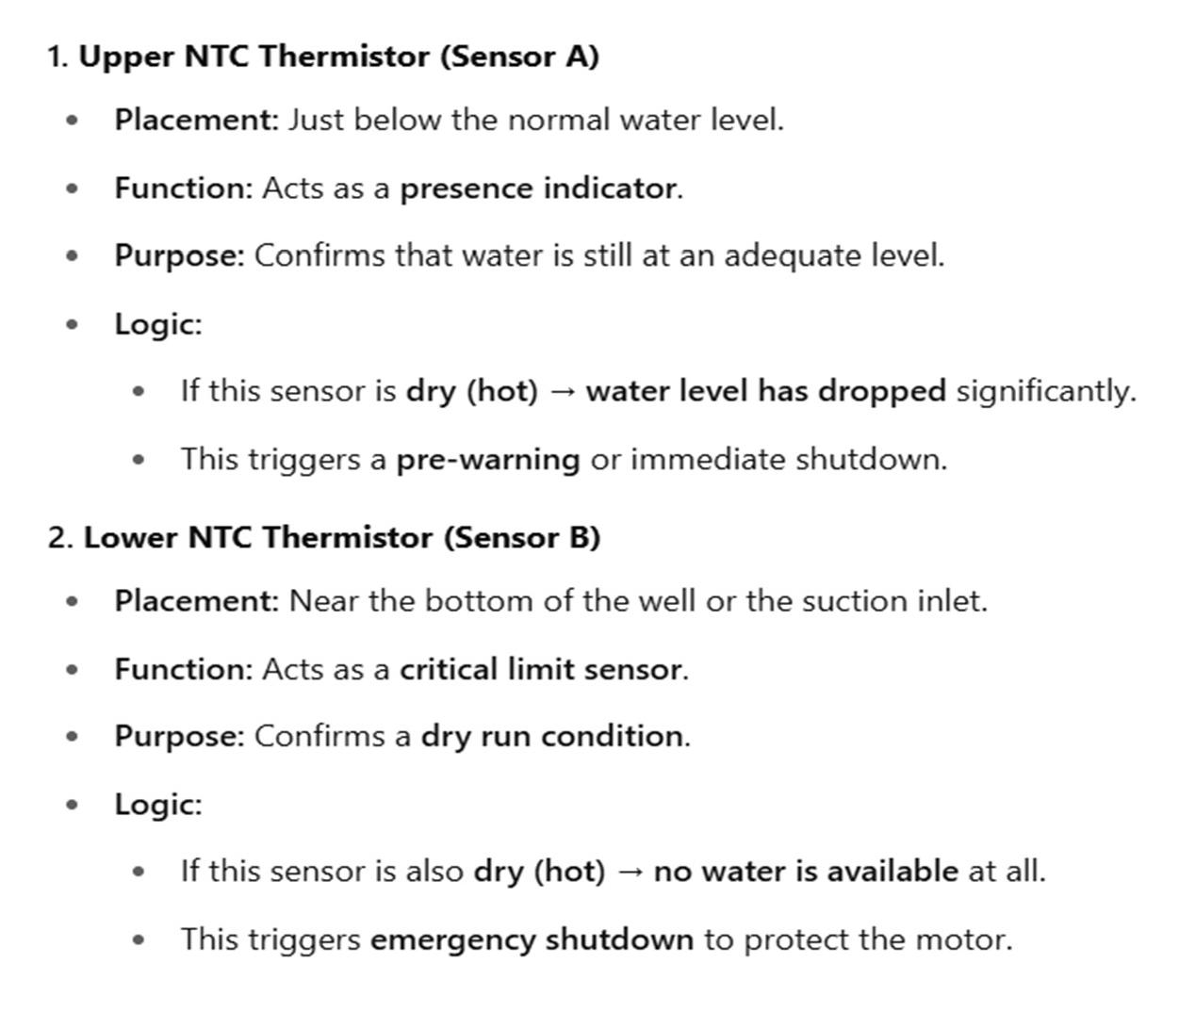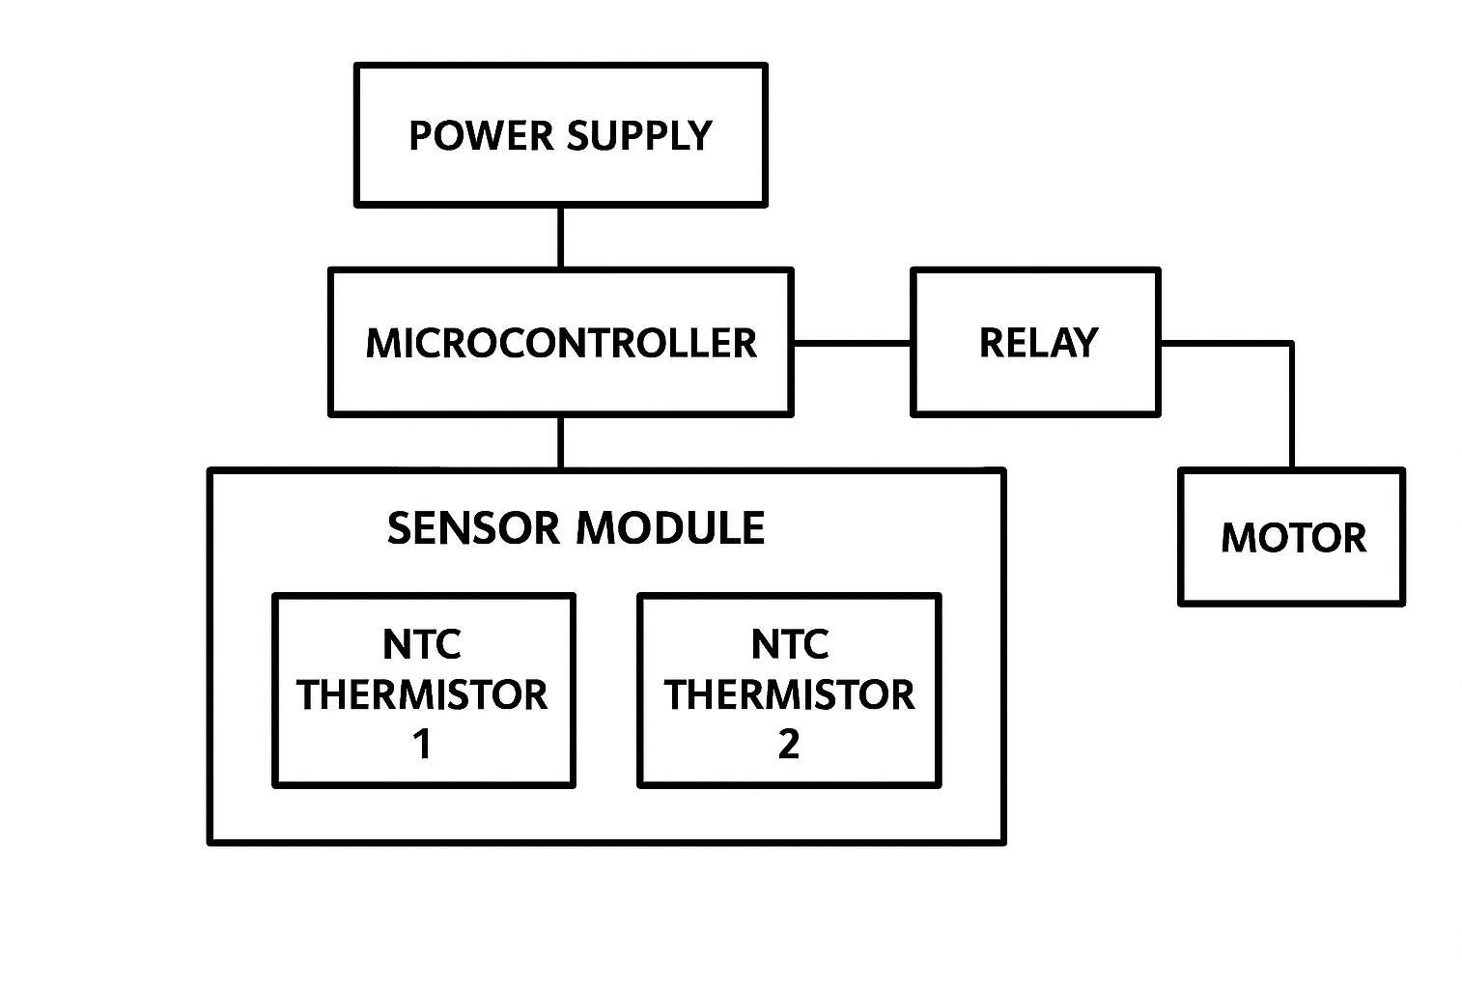

# Existing solutions

1. Monitoring the pressure in outlet pipe.
2. Monitoring the water level in the deep well through a water level sensor.
3. Monitoring the water at motor inlet through a rain drop sensor.

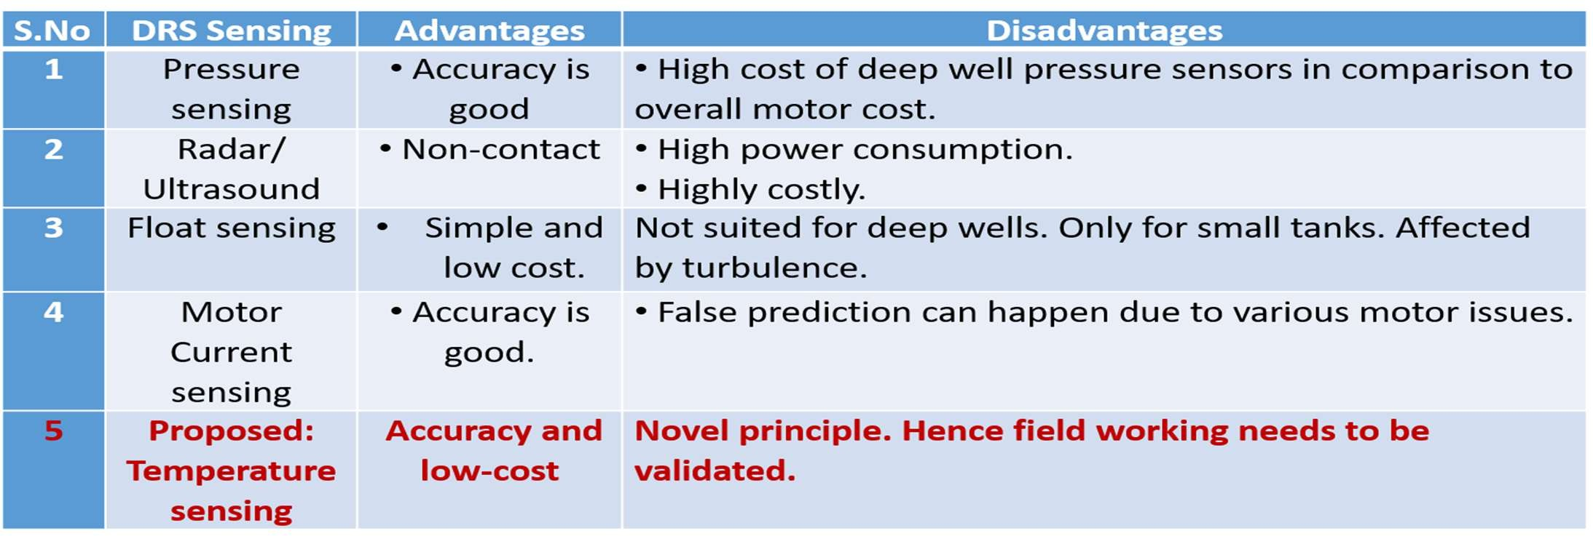

# BLOCK DIAGRAM

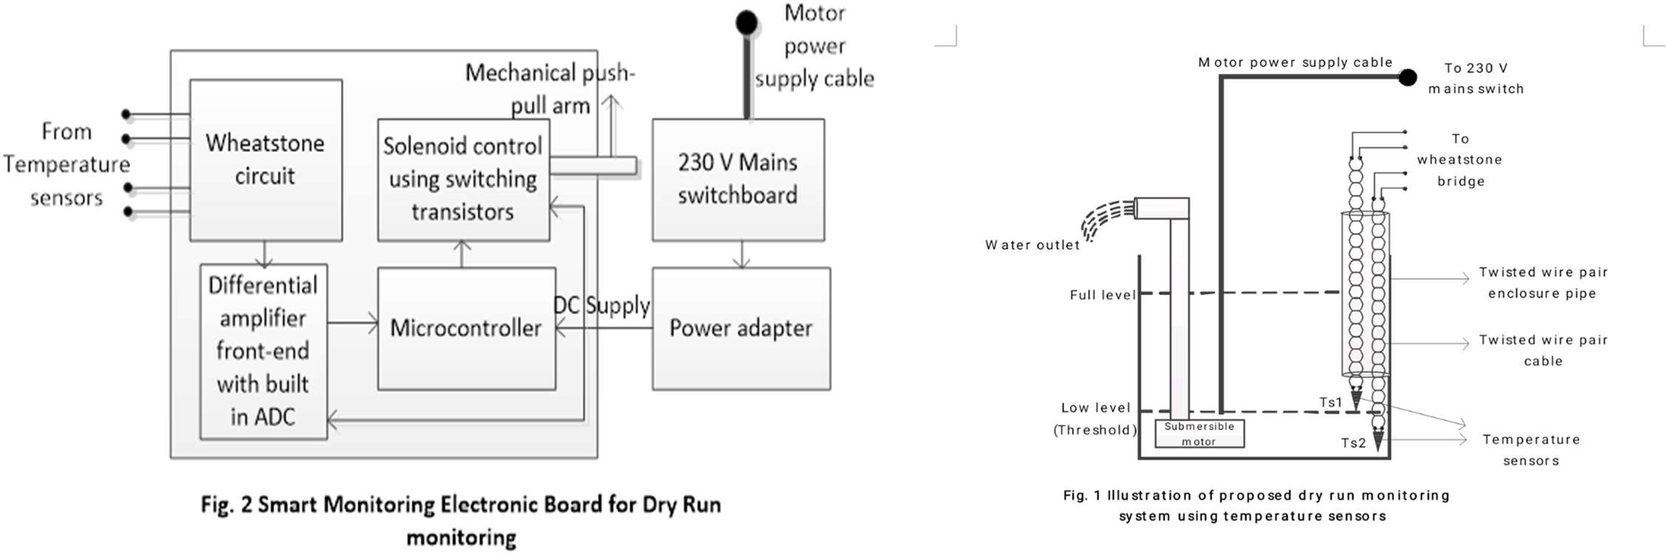

**COMPONENTS**

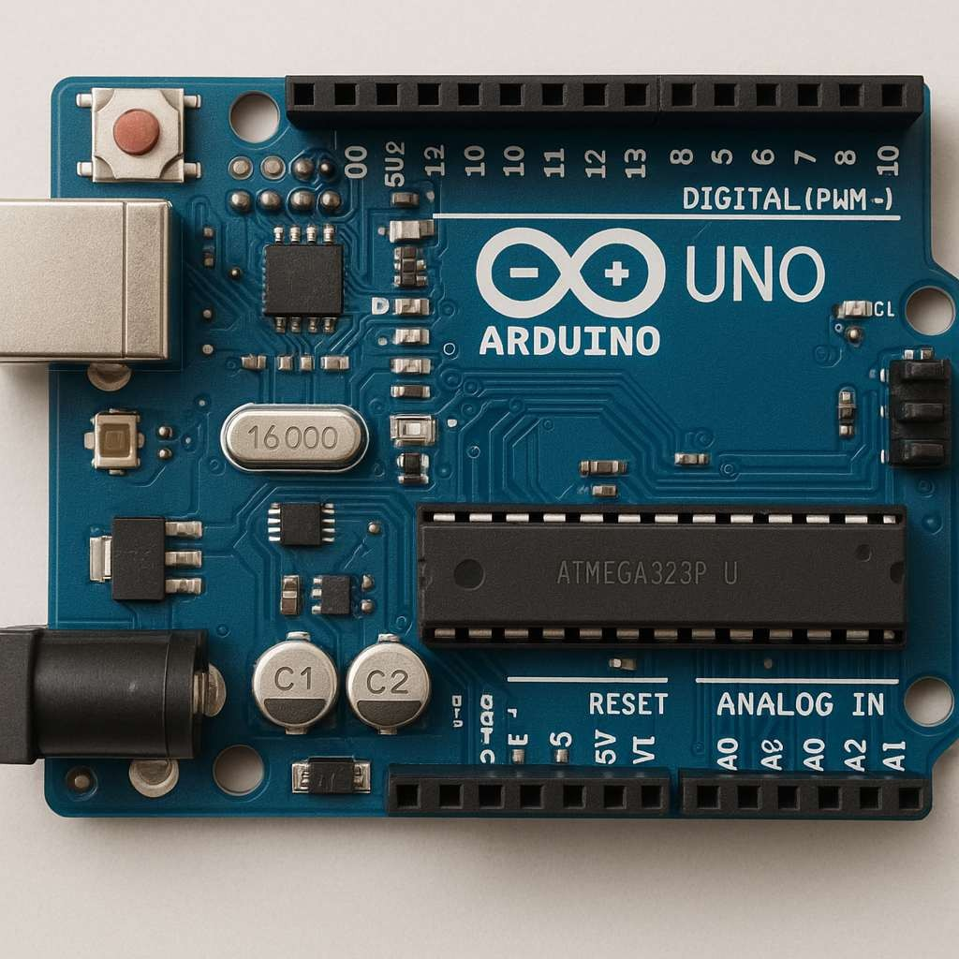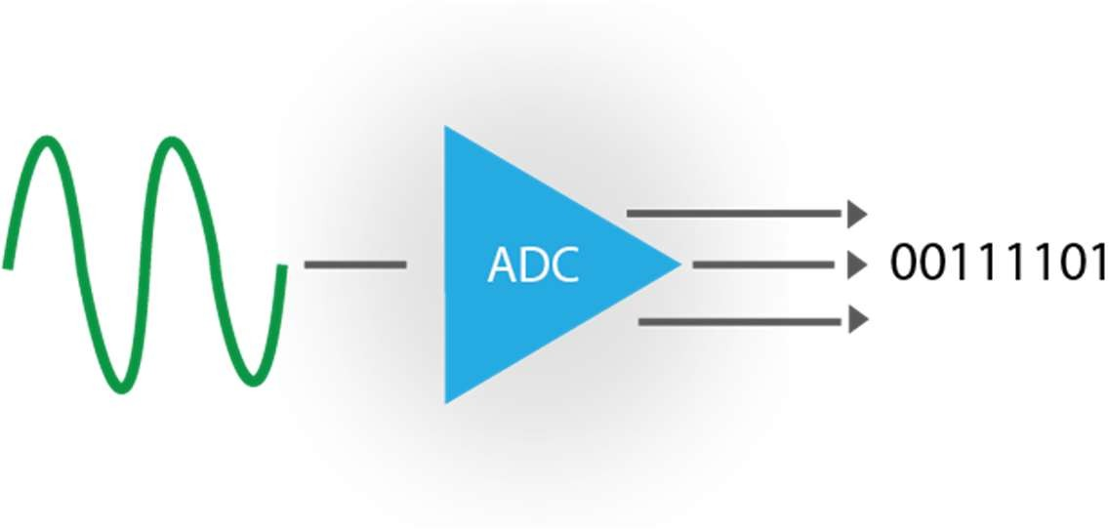

* **Mini computer on a chip**: A microcontroller is an integrated circuit that contains a processor, memory, and input/output (I/O) pins — all in one small package.
* **Designed for control tasks**: It reads sensor inputs, processes data, and sends commands to other devices like motors or displays.

**Converts analog signals to digital**: ADC takes real-world analog input and turns it into a digital number the microcontroller can understand.

**To read temperature changes from the T-sensor** and process them digitally for precise control of outputs like the relay or motors.

# COMPONENTS





**Precision measurement**: It’s a circuit used to measure small changes in resistance very accurately — ideal for temperature sensing using thermistors.



**To detect fine temperature differences more reliably**, especially when precise control is required — making the system more sensitive and stable than a simple resistive divider.

**Controlled by Arduino output**: The Arduino sends a digital HIGH/LOW signal to the transistor/relay, turning the solenoid ON or OFF when needed

**To create mechanical movement (like pushing, pulling, or triggering)** in response to temperature changes — allowing physical control or action (like opening a vent or pressing a button) in automation setups.

Proof-of-concept implementation

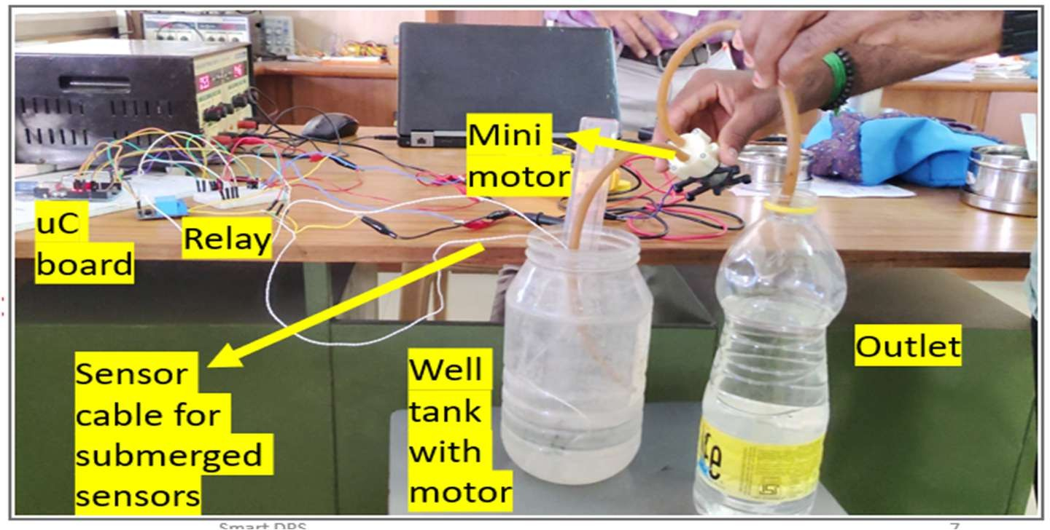

**OUTPUT**

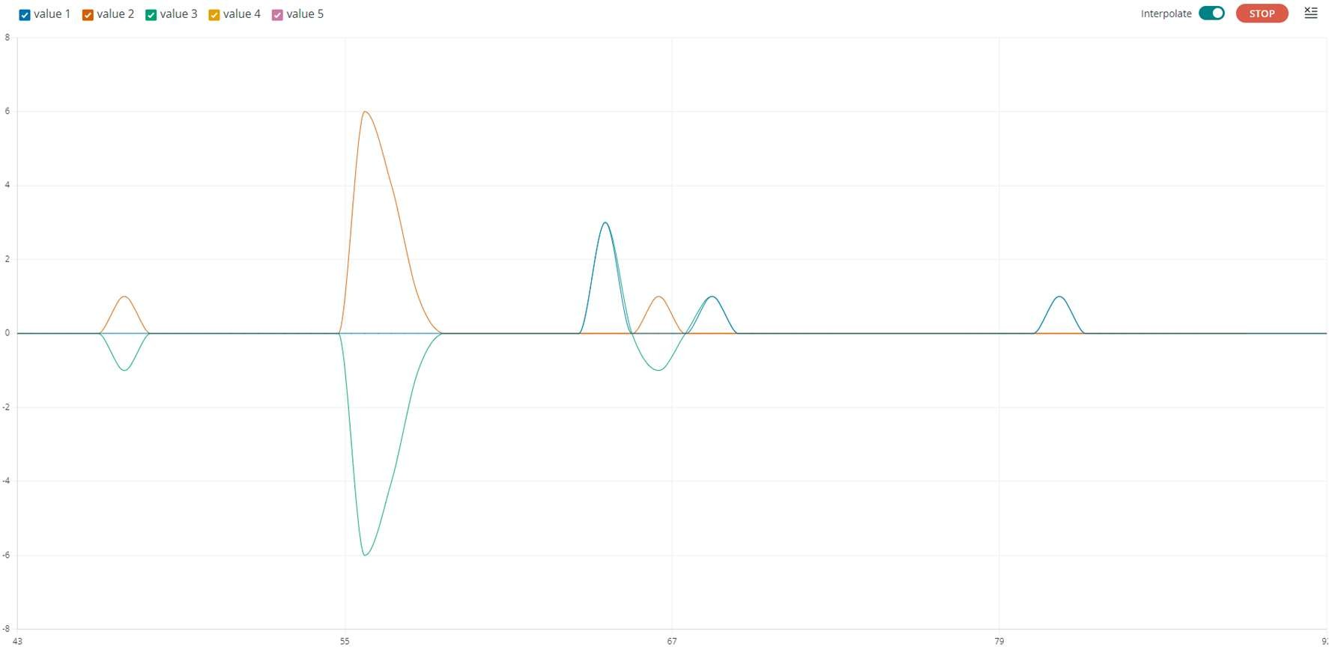

**DIFFERENTIAL SENSOR OUTPUT**

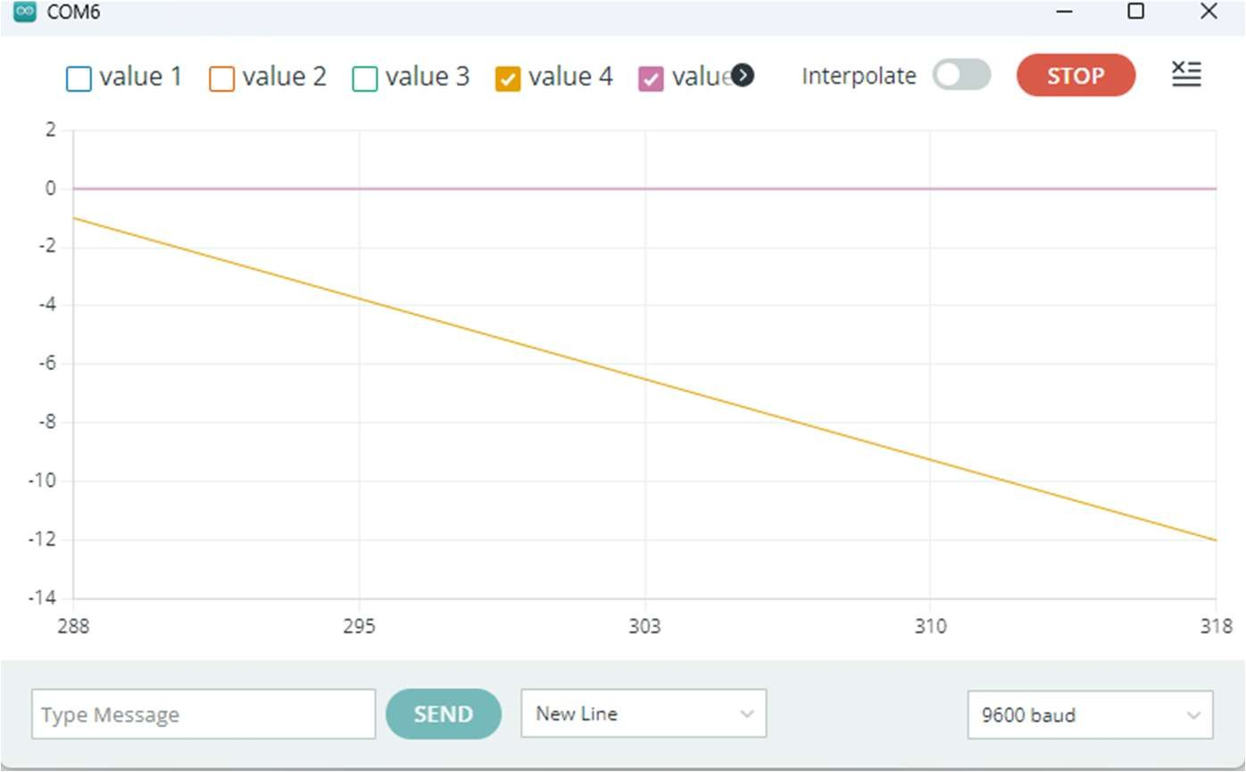

**CONCLUSION**



